BUSINESS COMMUNICATION SYSTEMS COURSEWORK

MUSEUM EXHIBITION

**Toys Exhibition**

**Introduction**

This coursework will focus on toys exhibition in an existing museum called Batcat Museum and Toys in Thailand and how information can be communicated with visitors. A toy exhibition is selected as is a suitable option for a school trip since according to research from www.economist.com the toy industry has experienced a growth of up to 5% in 2012 reflecting on the fact that people are spending more on toys. Nowadays, women are having children at a later age when they have more money; that is, more disposable income which can be spent on leisure activities that may be of interest to their child.

*(Source:* [*http://www.economist.com/blogs/schumpeter/2013/09/toy-industry*](http://www.economist.com/blogs/schumpeter/2013/09/toy-industry)*)*

**Artefacts**

The artefacts that will be exhibited in the museum are mainly targeted to growing children. The development of new technology have greatly changed the consumer tastes in toys and games; shifting the market to more electronic based entertainments. This is supported by the research by the Global Industry Analysts stating that, “Market growth is being fuelled by video, console and computer games…this group takes a greater interest in games as a popular leisure pursuit,” and that most children experience the character in digital before physical play. Thus, to attract the attention of the target audience, toys related to popular video games or movies will be displayed as they are well known and liked by children who will then experience greater appreciation of the toys and therefore increasing their values.

*(Source:* [*http://www.reportlinker.com/ci02218/Toy-and-Game.html*](http://www.reportlinker.com/ci02218/Toy-and-Game.html)

[*http://www.economist.com/blogs/schumpeter/2013/09/toy-industry*](http://www.economist.com/blogs/schumpeter/2013/09/toy-industry) *)*

Nostalgic toys would also serve to attract attention from adults who would like to share their childhood fun with their children. As supported by the key trend research by the toys association, “nostalgic parents, who in turn want to share their favourite childhood memories with their children.” The mixture of new and old toys, from the first Rubik’s cube to newest Iron Man figure, exhibited in the museum will be suitable for family or school trip where the adults would enjoy seeing these nostalgic toys and children would be interested in the more modern toys. The prototype of the Rubik’s cube may also attract the attention of those who are interested in the origins or history of modern toys as it is the first cube puzzle ever invented.

*(Source:* [*http://www.toyassociation.org/TIA/Industry_Facts/trends/IndustryFacts/Trends/Trends.aspx#.UnmZf9JHLTo*](http://www.toyassociation.org/TIA/Industry_Facts/trends/IndustryFacts/Trends/Trends.aspx#.UnmZf9JHLTo)*)*

To make the exhibition interesting for both genders, there is a mixture of toys ranging from classic doll like Barbie that will attract attention from girls and more masculine toy such as iron man figures. Rubik’s cube and Lego are also popular amongst both genders.

**Corporate Identity**

To keep a professional look to the exhibition, the corporate identity of the exhibition must be kept consistent. This is a way of branding or trademarking to form a distinction between the museum and other competitors making the exhibition more recognisable. As analysed from the logo and building structures of Batcat Museum and Toys Bangkok, the main corporate colours are yellow, blue and grey which will be used throughout the design in order to reinforce the corporate identity. The text font used will be MV Boli since there is quite a comic look to the font which is fitting for toy museums.

*(Source:* [*http://en.wikipedia.org/wiki/Corporate_identity*](http://en.wikipedia.org/wiki/Corporate_identity)*)*

The choice of blue colour as the main corporate colour comes from the research of the effect of blue on visitors and why most popular websites such as Facebook, Skype or Twitter uses blue in their design. The blue colour is gender neutral as both men and women prefer blue overall and is therefore liked by both genders. It is also a symbol of “knowledge, solemnity, integrity and expertise” which are images that companies aim to create.

*(Source:* [*http://www.webnotwar.ca/feeling-blue-why-the-most-popular-websites-are-blue/*](http://www.webnotwar.ca/feeling-blue-why-the-most-popular-websites-are-blue/)*)*

**Communication**

Museums are sources of information but unlike schools and classrooms, learning in museum is completely voluntary and self-directed so great care must be taken in the presentation of information since visitors may easily choose to ignore information delivered in an unclear or difficult to find manner. Medium of communication used in this exhibition, therefore, must deliver the contents of the museum and provide incentives for attending to this content.

*(Source:* [*http://infed.org/archives/e-texts/screven-museums.htm*](http://infed.org/archives/e-texts/screven-museums.htm)*)*

Since museums are audience centred rather than product lead, they must understand the visitors’ motivation and needs. In this case, all advertisements were created with primary school teachers and the students as target customers promoting educational school trips to the museum’s exhibition.

*(Source:* [*http://www.intercom.museum/documents/1-4Waltl.pdf*](http://www.intercom.museum/documents/1-4Waltl.pdf)*)*

**Database**

The information about the artefacts to be displayed in the museum is stored in a simple flat file database. A simple flat file database is sufficient for organising and keeping accurate records of the artefact and there is no need for relational database since each artefact are completely independent from the other artefacts and no fields need to be related to a separate database.

A database is used instead of a manual system since it can store large amount of information in a smaller space and saves time through the use of a simple query and the correct keywords to recall information instead of having to manually look through piles of paperwork, especially when there are large amount of data. Data can also be accessed at the same time and in different places so this makes data more accessible.

*(Source:* [*http://www.life123.com/technology/computer-software/database-software/advantages-of-using-a-database.shtml*](http://www.life123.com/technology/computer-software/database-software/advantages-of-using-a-database.shtml)*)*

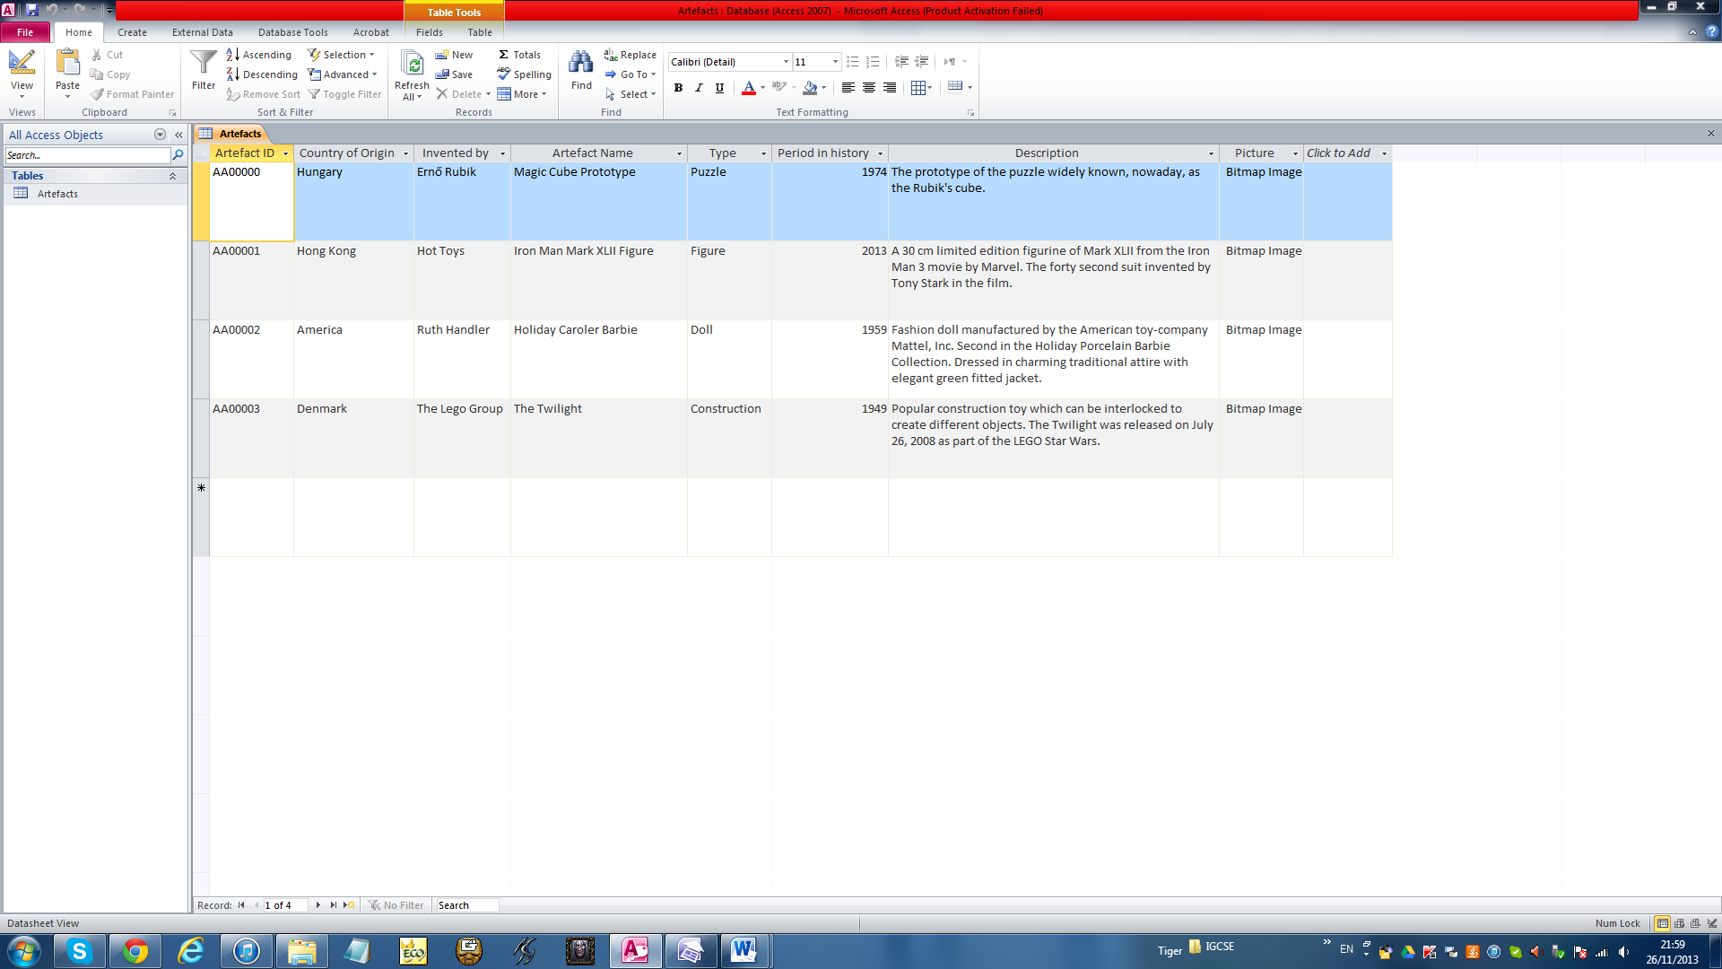

Structure:

In order to create a well-structured and efficient database, normalisation must be considered when deciding which data and fields to include in the database. This database follows the third normal form (3NF). For a database to be in the third normal form, it has to follow both the first and the second normal form which prevents redundancy of data. This is done by having a single key field where all the other non-key fields such as country, name, inventors and descriptions are dependent upon. A well-structured database will be able to display data clearer and make finding the necessary information easier and quicker.

*(Source:* [*http://www.yourinspirationweb.com/en/database-structuring-the-normalization/*](http://www.yourinspirationweb.com/en/database-structuring-the-normalization/)*)*

Fields:

Database fields are components of a database that stores discrete bits of information where the field name dictates what data are to be entered in the field. These should be kept succinct and easy to understand so that users know exactly what to put in the database. To break down the data in this database, each field contains atomic data where different data is not grouped in one field.

Field Length:

A fixed length field is used in order to reduce storage space taken up by the field. This reduces the file size as well as makes the allocation of storage space simpler since each record requires the same amount of space.

*(Source:* [*http://www.hollyfield.kingston.sch.uk/gcseit/GCSE/database.htm*](http://www.hollyfield.kingston.sch.uk/gcseit/GCSE/database.htm)*)*

Information:

Key information including brief descriptions about each artefact is inputted to the database. Museums are popular amongst tourists mainly because they are interested in the history of the artefacts and a museum would be the best place that has a collection of these interesting artefacts. The reason for including a description is as suggested by Kim Kenney, curator of the [William McKinley Presidential Library and Museum](http://en.wikipedia.org/wiki/William_McKinley_Presidential_Library_and_Museum), “people want specific aspects of the object they might not notice at first glance”. Therefore, the description stored in the database can be put on display next to the artefacts on the object labels (record cards). The data type used for storing this information is short text which can contain 255 words and not long text since none of the records has word count exceeding 255 so this is done to save storage space.

*(Source:* [*http://en.wikipedia.org/wiki/Museum_label*](http://en.wikipedia.org/wiki/Museum_label)*)*

Data Types:

The use of data types suitable for each field will allow data to be validated since data may be entered by different people and this can cause errors and inconsistency of data. Field types can be used to make sure that data entered are in the same format and that they are the correct information. This is to make finding information in the database easier for the user as data are organised.

Below is a table showing the key data types and validations applied to each field:



As shown by the table, most data type used is text which allows the information about each artefact with lots of variations to be entered in the field. However, the disadvantage is that the probability of errors occurring is higher. To make up for this, validation rules are applied and data entered can be verified afterwards.

Artefact ID:

The artefact ID is the unique field (primary key) for the database which uniquely identifies each artefact as well as not allowing null value in the field. This also ensures that there are no duplicates of records or no records are missing which prevents redundancy of data; that is, no useless data which will take up space in the database. To let the ID be in the same format for easy sorting and finding records, the input mask is set as LL00000 which means that there must be 2 letters followed by 5 numbers. If abnormal data is entered, a validation text that says, “The field must contain 2 letters followed by 5 numbers” will show as an error message so that the user knows how to correct the data.

Country of Origin and Invented by:

This field contains the basic information about the artefact and gives credit to the country and the person or company that invented it. This tells the visitor where the product originated.

Period in History:

The period in history field stores the information about the years in which the artefacts were first invented. Since the years contain only numbers, the field type is set as number; preventing any letters from being entered in the field. This ensures that only the correct type of data is entered in the field since years does not contain letters. The input mask is 0000 to allow only 4 numbers to be entered in the field and the validation rule is <2014 since there should not be artefacts displayed that will be invented in the future. Making sure that the information about the date is entered correctly is important for clear communication since museums should be a credible source of information for educational purposes as previously mentioned in the “Communication” section.

Since validation rules and input masks were set, they have to be tested to make sure that the rules work and will return an error message when abnormal data is entered. To do this, normal, abnormal and extreme data were entered in the field.

Language:

Since the database is going to be used for the record cards which must be readable by the visitors, the language used must be suitable for both children and adults. Therefore, short and simple language is used to communicate the information while giving enough important details about the artefacts.

Picture:

A picture field is included to allow picture files to be attached to the database. Attaching a picture will make identifying the actual artefact displayed in the museum easier. All images were saved as bitmap images which is the only type of image that is accepted by Microsoft Access. The field type is OLE Object which allows images to be linked to the database.

**Record Card**

To produce an A6 record card, the mail merge function was used to merge the database created (data source) with the record card template (main document). Merge fields were then inputted which marks the position where data from the database are to be entered. Mail merging ensures that the format is consistent and saves time entering the data about the artefacts onto the card.

Microsoft word was used instead of the label wizard on database since it is easier to set the layout and format of the record card to make it more attractive due to the limitations of database to set decorations such as colours and borders.

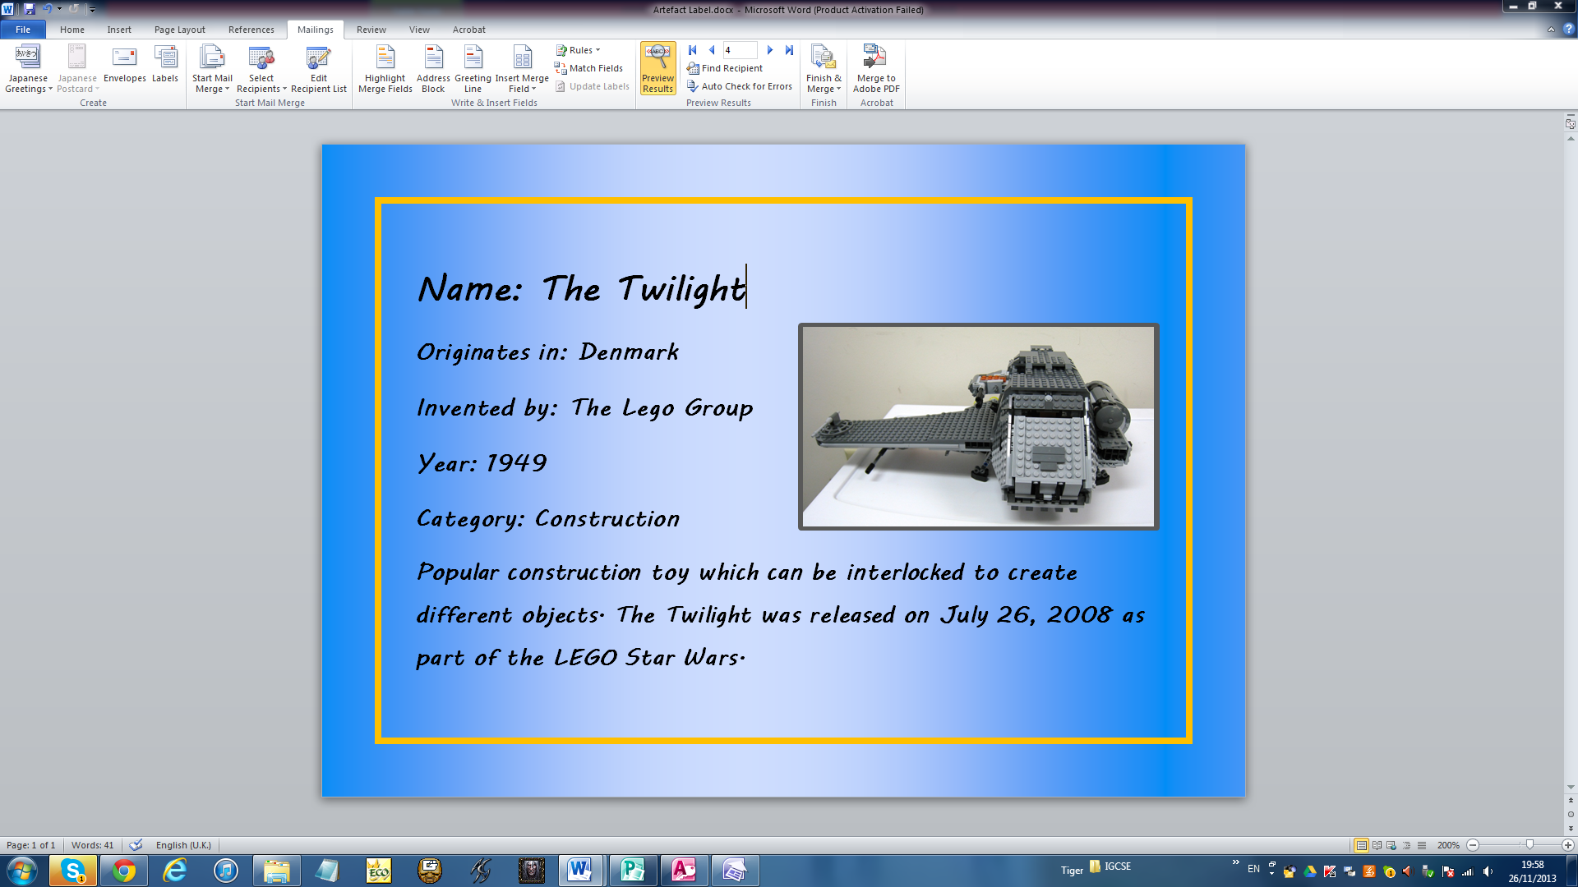

Colour:

The colours used are the three colours from the corporate colours mention previously to keep the identity of the company consistent. Text font is also kept as MV Boli.

A warm yellow-orange colour is used as the border for the record cards based on the psychology of the warm colours, “Warm colours are some of the best colours for advertising…A colour scheme that incorporates warm colours also encourages people to linger”. This is suitable for object labels for the artefacts since it draws information to the card.

*(Source:* [*http://www.wisegeek.org/what-are-the-best-colors-for-advertising.htm*](http://www.wisegeek.org/what-are-the-best-colors-for-advertising.htm)*)*

Using a cool colour such as dark blue as the background colour in contrast with the warm colour helps to create a balance between the excitement and calmness. The blue colour has a calming effect shown in the psychological properties of colour, “serene and mentally calming. It is the colour of clear communication.” The visitor can be detached from the chaotic world as they immerse in a world surrounded by toys from famous fictions.

*(Source:* [*http://www.colour-affects.co.uk/psychological-properties-of-colours*](http://www.colour-affects.co.uk/psychological-properties-of-colours)*)*

Border:

Using a border as decoration helps to focus the reader’s attention to the information as it outlines the part where the visitor is expected to look at and people would normally see inside the border. This is important as there will be many people walking around the museum looking at different artefacts displayed in the exhibition and we want them to get the information at a glance as they walk by.

Contents:

The information that will be used to classify and describe the artefacts includes the name, the country in which the artefacts originated in, the person or company that invented the artefact, the year in which it was first produced, category and a brief description.

The name of the artefact is and important information that tells the reader what the object displayed is as people may sometimes recognise the artefact by its name. The category puts the artefacts in different classifications of toys such as puzzle, figurine and construction. The only field from the database that is omitted from the record cards is the artefact ID field since it is a field that just helps to uniquely identify the object and is not related to the actual data on the artefact itself.

There is a border for where the picture of the artefact is to be placed which will help to clarify which artefact the record cards are giving information about. A picture is included in the corner of the label even though it is placed next to the artefact because it links the artefact to the information and also helps to ensure that the label was placed next to the correct artefact.

**Webpage**

Advertising:

A website is created as an online advertisement to provide information for visitors to make them aware of the location and time of the exhibition. Nowadays, online advertising has become more popular due to the wide reach of the internet making it one of the most powerful tools of advertising.

*(Source:* [*http://ezinearticles.com/?Purpose-of-Online-Advertising&id=1990127*](http://ezinearticles.com/?Purpose-of-Online-Advertising&id=1990127)*)*

Content:

It is important to make the content of the webpage short but not too short since people skim when visiting webpages online and they should be able to get the information quickly at a glance. A good navigation bar that is easy to use is the critical part of a webpage because people will be discouraged to carry on reading if the webpage is confusing and difficult to navigate around. Information entered is re-read after typing to check that the grammar and spellings are correct.

Museums:

To research information about the structures of the website, different webpages from a range of museums were investigated. These are listed below:

* <http://themilltoymuseum.com/>
* <http://www.apple.com/>
* <http://www.metmuseum.org/exhibitions>
* <http://www.tourismthailand.org/See-and-Do/Sights-and-Attractions/Museums>

From these webpages, it can be noted that all of them have navigation bars at the top of the page which is easily accessible for visitors. Another essential component is the contact us tab which gives contact information and address of the location. The use of picture is also consistent throughout the designs. What is seen in common in some of these webpages are exhibition tabs on the navigation bar which leads to a page giving information on the past and upcoming exhibitions.

The following conclusion is made on the design of the webpage for the task based on the research:

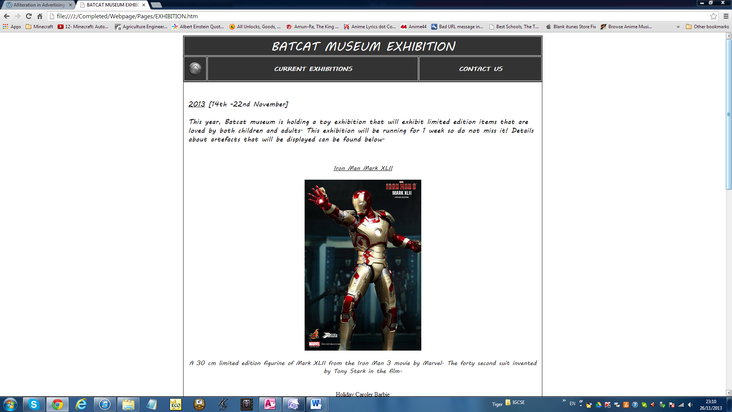

Design:

To keep the corporate identity consistent throughout the whole design, the colour scheme used for the webpage is yellow, blue and grey and the font used is MV Boli which, again, is the same as the font used in the record card.

The home page introduces the museum and uses combination of picture and choice of language to grab the reader’s attention. Since the museum is targeting primary school teachers who may want to arrange a trip to the museum, information is given about the booking for a visit at the museum.

The exhibition page informs the reader about the exhibitions currently taking place at the museum and includes the time period for the exhibition in large, bold text. Pictures of the artefacts are placed with their brief description to let the potential customers see what is to be expected at the museum.

The last tab is the contact us tab which gives a clear map to the museum to make it easy for people interested in the exhibition to visit the museum. This is convenient for the visitors because they do not have to go and find a map themselves which can be irritating and discourages them from visiting.

Navigation:

The website is easy to navigate around with a navigation bar at the top of the page. Mouse-over effects are also applied to the hyperlinks and the home icon. According to a survey, “rollover effects not only add visual interest to a Web page but also improved click-through rates by approximately 30%.” This interaction makes visitors feel more connected to the site.

*(Source:* [*http://www.cs.umd.edu/~mount/Indep/CHassan/navbar.htm*](http://www.cs.umd.edu/~mount/Indep/CHassan/navbar.htm)*)*

An anchor (bookmark) is placed at the top of the page to help the visitor quickly navigate back to the top of the page once they reach the bottom. This helps save time and the amount of scrolling required.

*(Source:* [*http://help.yahoo.com/l/us/yahoo/smallbusiness/webhosting/ghtml/ghtml-14.html*](http://help.yahoo.com/l/us/yahoo/smallbusiness/webhosting/ghtml/ghtml-14.html)*)*

**Leaflet**

Leaflets are relatively inexpensive method of communicating and a tri-fold leaflet is used in this case since it is the most common type of leaflet and can fit enough information with good spacing. The leaflet is aimed at primary school teachers which could be potential customers to create awareness of the exhibition. The information given in the leaflet also directs customers to the online website which will provide them with further information and gives the contact details that the teachers can use to arrange their visits.

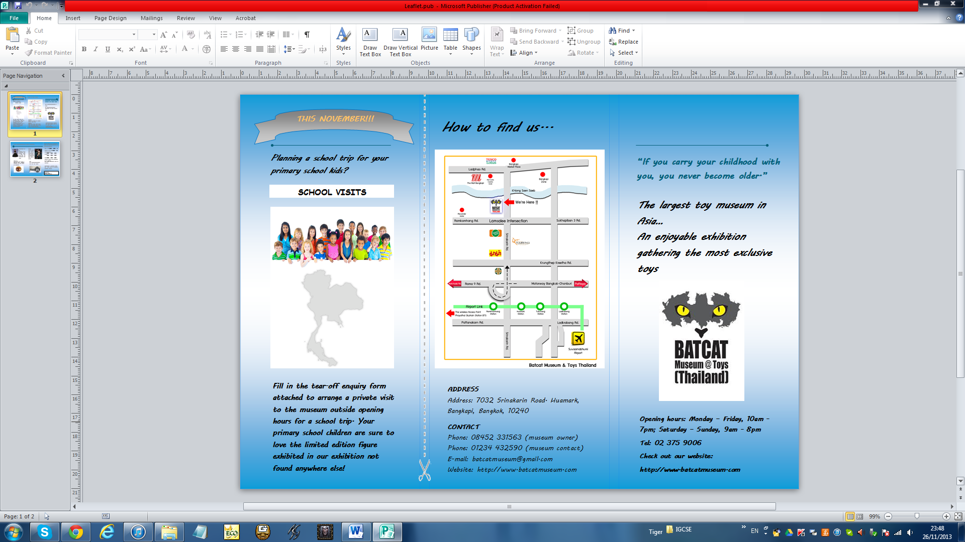

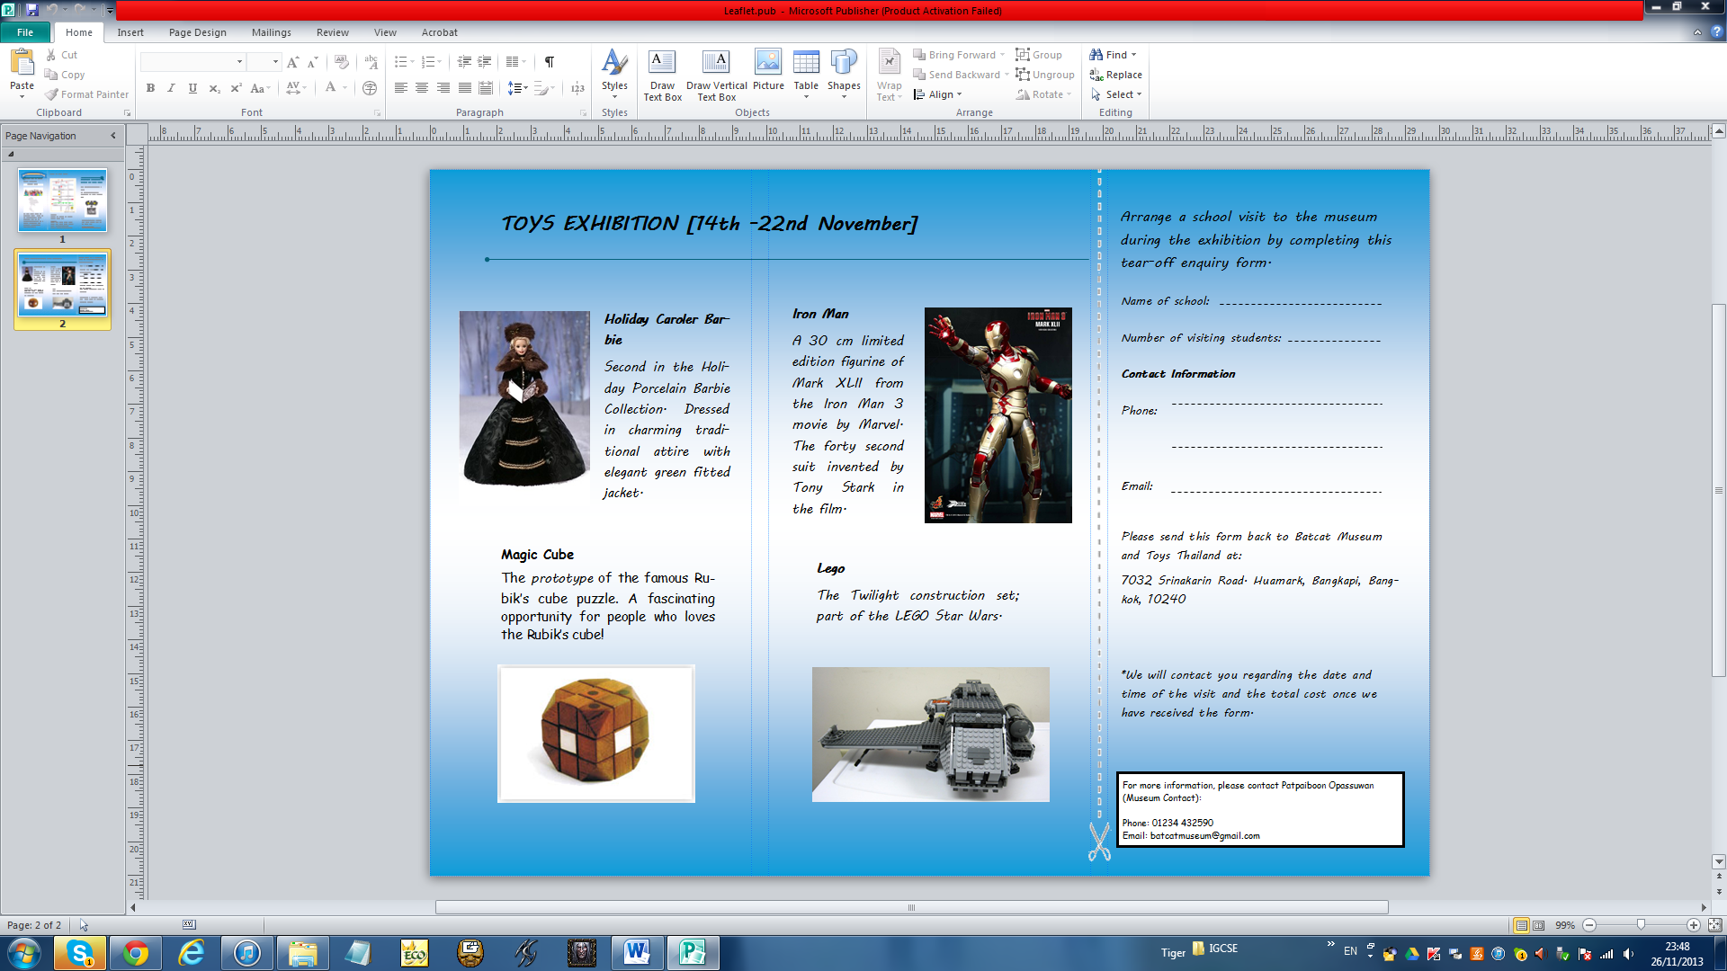

Spacing:

The leaflet will have to be printed and folded into three sections with three panels on each side (tri-fold leaflet). To do this, a leaflet template in Microsoft publisher was used to mark the panels so that no images or text goes over the fold as it will make

Front Panel:

The front panel of the leaflet should grab attention as soon as the leaflet is picked up and this is done by using the quote, “The largest toy museum in Asia…An enjoyable exhibition gathering the most exclusive toys.” The quote uses consonance which is a literary tool used in many advertising since the repetition of consonant sounds makes the quote more memorable and therefore increases the chance of attention being drawn to the exhibition.

*(Source:* [*http://poetryinpublic.wordpress.com/2013/02/16/alliteration-in-advertising-and-other-aspects/*](http://poetryinpublic.wordpress.com/2013/02/16/alliteration-in-advertising-and-other-aspects/)*)*

A logo of the Batcat Museum and Toys is included on the front page to promote the brand but care is taken to not let the image overshadow the important message by using a larger font for the quote.

*(Source:* [*http://www.psprint.com/resources/creating-professional-trifold-brochures/*](http://www.psprint.com/resources/creating-professional-trifold-brochures/)*)*

After successfully grabbing the reader’s attention, they may turn to the smaller texts which will give them the museum’s contact information and opening hours. The text is written in smaller font as it is more important to get the message across about the exhibition at Batcat Museum than how to contact the museum.

An interesting quote by Tom Stoppard, “If you carry your childhood with you, you never become older,” is very suitable for this toy museum which target audience is both children and adults (school teachers) and this serves to persuade them to come to visit the museum and experience their childhood.

Centre Back Panel:

The centre back panel is another one of the first panel to be seen on the leaflet. Therefore, essential information such as map , address and contact information which are needed for potential customers to actually come and visit the museum is placed on the back. The map is clear and includes noticeable locations nearby to make it easier to find the museum. Simple and short language, “How to find us…” is positioned at the top of the page to lead the reader to the map.

Tear-off Enquiry Form: